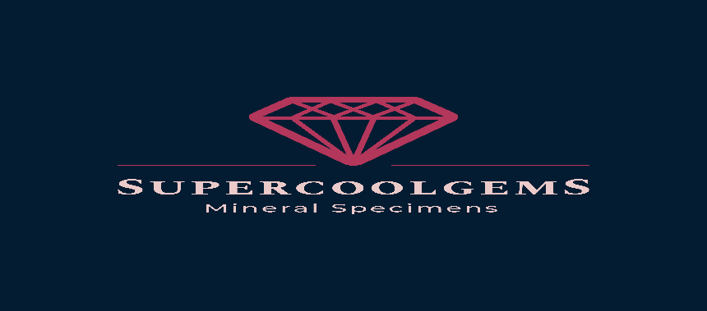

*WE OFFER UNIQE AND RARE MINERAL SPECIMENS*

*HERE IS THE LIST OF WHAT WE WILL HAVE IN STOCK FROM NOW ON*

|  |  |  |  |  |
| --- | --- | --- | --- | --- |
| TYPE OF MINERAL | PRICE PER BOX * | PRICE PER MINERAL ** | ORIGIN | QUANTITY |
| **MIXED BULGARIAN BOX 10-20pieces\*\*\*** | £130-£200 | £5-£200 | BULGARIA | **100+BOXES\*\*\*\*** |
| *GALENA* | - | - | BULGARIA |  |
| *CUBIC GALENA* | - | - | BULGARIA |  |
| *SKELETAL GALENA* | - | - | BULGARIA |  |
| *SPHALERITE* | - | - | BULGARIA |  |
| *GEM SPHALERITE VIA CLEIOPHANE* | - | - | BULGARIA |  |
| *PYRITE* | - | - | BULGARIA |  |
| *FOOLS GOLD* | - | - | BULGARIA |  |
| *IRON PYRITE* | - | - | BULGARIA |  |
| *QUARTZ* | - | - | BULGARIA |  |
| *MILKY QUARTZ* | - | - | BULGARIA |  |
| *CLEAR QUARTZ* | - | - | BULGARIA |  |
| *FANTOM QUARTZ* | - | - | BULGARIA |  |
| *CHRYSOPRASE QUARTZ* | - | - | BULGARIA |  |
| *CHALCOPYRITE* | - | - | BULGARIA |  |
| *CALCITE* | - | - | BULGARIA |  |
| *FLUORISCENT MANGANO CALCITE* | - | - | BULGARIA |  |
| *ORANGE CALCITE* | - | - | BULGARIA |  |
| *MINERALS WITH LIMONITE* | - | - | BULGARIA |  |
| *CHALCEDONY COMBINATIONS* | - | - | BULGARIA |  |
| *ORPHEUS AGATE* | - | - | BULGARIA |  |
| MAGNIFICENT COMBINATIONS | - | - | BULGARIA |  |
| FLUORITE | £180-£250 | £15-£100 | SPAIN | 5+BOXES |
| CELESTINE | £130-£180 | £10-£50 | MADAGASCAR | 5+BOXES |
| VANADINITE | £130-£180 | £10-£50 | MOROCCO | 5+BOXES |
| CARBORUNDUM | £130-£150 | £5-£50 | BRAZIL | 5+BOXES |
| DESSERT ROSE | £130-£150 | £10-£50 | MOROCOO | 5+BOXES |
| AZURITE | £130-£150 | £5-£30 | MOROCOO | 5+BOXES |
| MALACHITE WITH ANKERITE | £130-£150 | £5-£30 | CONGO | 5+BOXES |
| BLACK TOURMALINE | £100-£150 | £5-£20 | MADAGASCAR | 5+BOXES |
| ARAGONITE | £100-£150 | £5-£20 | SPAIN | 5+BOXES |
| LABRADORITE | £50 | £3-£10 | MADAGASCAR | 5+BOXES |
| MIX MOROCCO | £65 | £3-£10 | MOROCCO | 5+BOXES |
| AMETHYST BRAZIL | £50 | £3-£10 | BRAZIL | 5+BOXES |
| AMETHYST URUGUAY | £65 | £5-£15 | URUGUAY | 5+BOXES |
| CITRINE | £50 | £5-£15 | BRAZIL | 5+BOXES |
| PINK GEODE | £50 | £5-£50 | MOROCCO | 5+BOXES |
| PURPLE GEODE | £50 | £5-£50 | MOROCCO | 5+BOXES |
| BLUE GEODE | £50 | £5-£50 | MOROCCO | 5+BOXES |
| QUARTZ GARNET | £50 | £5-£50 | MADAGASCAR | 5+BOXES |
| ROSE QUARTZ | £65 | £5-£50 | MADAGASCAR | 5+BOXES |
| AGATE GEODE | £70 | £5-£50 | MOROCCO | 5+BOXES |
| BLUE AGATE | £60 | £5-£50 | BRAZIL | 5+BOXES |
| PINK AGATE | £60 | £5-£50 | BRAZIL | 5+BOXES |
| PURPLE AGATE | £60 | £5-£50 | BRAZIL | 5+BOXES |
| NATURAL AGATE | £60 | £5-£50 | BRAZIL | 5+BOXES |
| RED AGATE | £60 | £5-£50 | BRAZIL | 5+BOXES |
| GREEN AGATE | £60 | £5-£50 | BRAZIL | 5+BOXES |
| MIXED SOUVENIRS CRYSTAL TREES | ANIMALS | SHAPES | AND MANY | MORE |

*approximate sizes for the box 30cm/40cm. Minerals per box from 7-25 depending on the minerals sizes

**prices per mineral depend of - type of the mineral, size, origin, quantity, etc.

***minerals from Bulgaria ONLY can be mixed types of minerals or same. Also can be combine with other minerals for an extra cost.

****all the minerals are subject of availability and can be reserved for 10 days for small deposit

The prices doesn’t include DELYVERY CHARGE AND VAT. The price CAN BE NEGOTIATED reasonably.

We are not offering returns but we will do everything possible to satisfy your expectations.

You will receive exactly what you have seen and chosen!!!

Subscription Available!!!

Contacts:

<Tel:+447591318195>  

<Tel:+359893461918>  

Social media:  

[www.facebook.com/cooll.gems](http://www.facebook.com/cooll.gems)

[www.instagram.com/raoslavmradev](http://www.instagram.com/raoslavmradev)

[www.supercoolgems.co.uk](http://www.supercoolgems.co.uk)

[www.supercoolgems.com](http://www.supercoolgems.com)

[www.supercoolgems.uk](http://www.supercoolgems.uk)

[www.supercoolgems.net](http://www.supercoolgems.net)

<https://www.etsy.com/uk/shop/BeautifulcolorBG?ref=simple-shop-header-name&listing_id=818025598>

<https://www.ebay.co.uk/usr/supercoolminerals?_trksid=p2047675.l2559>